1. Login to MySQL and view all databases already present. You should get following result :
Show Databases:
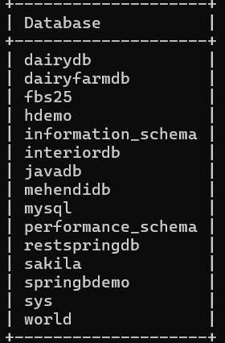
2. Write an SQL statement to create a simple table countries including columns country_id, country_name and region_id. After this display the structure of table as below :
mysql> create table countries
-> (country_id int(11), country_name varchar(20),
-> region_id int(11));
ERROR 1046 (3D000): No database selected
mysql> use fbs25;
Database changed
mysql> create table countries
-> (country_id int(11), country_name varchar(20),
-> region_id int(11));
Query OK, 0 rows affected, 2 warnings (0.06 sec)

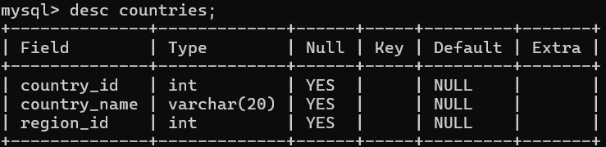

3. Write an SQL statement to create a table named jobs including columns job_id, job_title, min_salary, max_salary and check whether the max_salary amount exceeding the upper limit 25000. Also set job_id as primary key and entering null values for job_title is not allowed.
mysql> create table jobs
-> (job_id int primary key,
-> job_title varchar(20) not null,
-> min_salary double(7,2),
-> max_salary double check(max_salary>=25000));
Query OK, 0 rows affected, 1 warning (0.03 sec)
mysql> desc jobs;
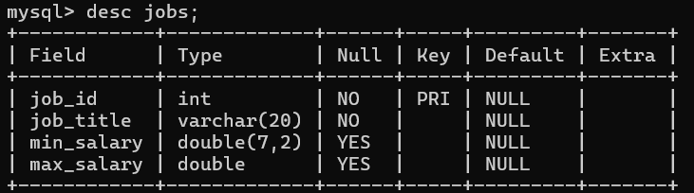
4. Write a SQL statement to create a table named job_histry including columns employee_id, start_date, end_date, job_id and department_id
mysql> create table job_history
-> (employee_id int,
-> start_Date date, end_date date,job_id int,
-> department_id int);
Query OK, 0 rows affected (0.03 sec)

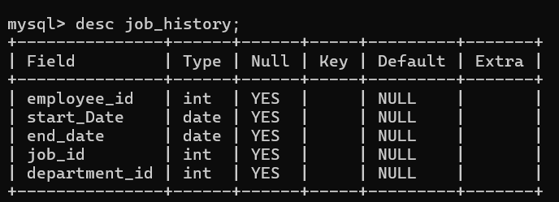
5. Write an SQL statement to alter a table named countries to make sure that no duplicate data against column country_id will be allowed at the time of
mysql> alter table countries
-> ADD CONSTRAINT unique_country_id UNIQUE (country_id);
Query OK, 0 rows affected (0.04 sec)

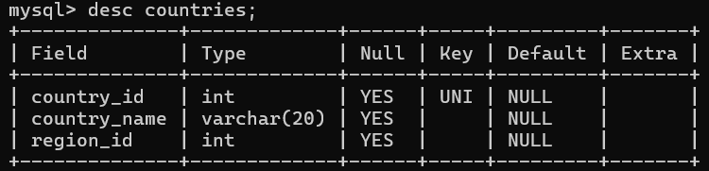

Write an SQL statement to create a table named jobs including columns job_id, job_title, min_salary and max_salary, and make sure that, the default value for job_title is blank and min_salary is 8000 and max_salary is NULL will be entered automatically at the time of insertion if no value assigned for the
specified columns.
mysql> CREATE TABLE jobss (
-> job_id INT,
-> job_title VARCHAR(20) DEFAULT '',
-> min_salary INT DEFAULT 8000,
-> max_salary INT DEFAULT NULL
-> );
Query OK, 0 rows affected (0.02 sec)

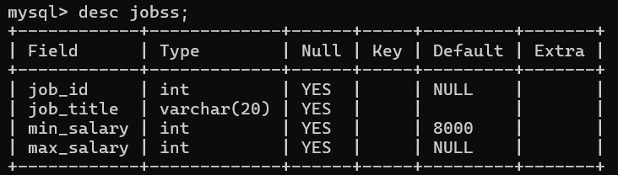

7. Create a Department table with following structure
mysql> create table department
-> (DEPARTMENT_ID decimal(4,0),
-> DEPARTMENT_NAME varchar(30) not null,
-> MANAGER_ID decimal(6,0) ,
-> LOCATION_ID decimal(4,0),
-> primary key (DEPARTMENT_ID, MANAGER_ID));
Query OK, 0 rows affected (0.02 sec)

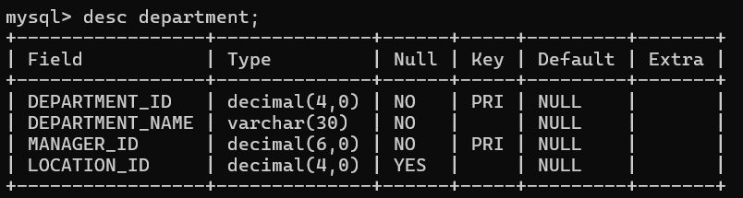

Write an SQL statement to create a table employees including columns employee_id, first_name, last_name, email, phone_number hire_date, job_id, salary, commission, manager_id and department_id and make sure that, the employee_id column does not contain any duplicate value at the time of insertion and the foreign key columns combined by department_id and
manager_id columns contain only those unique combination values, which combinations are exists in the departments table.
mysql> create table departments
-> (department_id int,
-> manager_id int,
-> dept_name varchar(50),
-> primary key(department_id, manager_id));
Query OK, 0 rows affected (0.02 sec)

Employee Table
mysql> CREATE TABLE employees (
-> employee_id INT PRIMARY KEY,
-> first_name VARCHAR(50),
-> last_name VARCHAR(50),
-> email VARCHAR(100),
-> phone_number VARCHAR(20),
-> hire_date DATE,
-> job_id INT,
-> salary DECIMAL(10, 2),
-> commission DECIMAL(5, 2),
-> manager_id INT,
-> department_id INT,
-> FOREIGN KEY (department_id, manager_id)
-> REFERENCES departments(department_id, manager_id) );
Query OK, 0 rows affected (0.03 sec)
